Battery Powered Car Air Conditioning

“The Chilly Dog”

Grant Franklin

Martin Rennaker

Yarentzy Magallanes

**Functional System Requirements**

REVISION – Draft

15 February 2022

Functional System Requirements

for

Battery Powered Car Air Conditioning

Prepared by:

Yarentzy Magallanes

Grant Franklin

Martin Rennaker

02/23/2022

_____________________________

Author Date

Approved by:

Martin Rennaker 02/23/2022

_____________________________

Project Leader Date

02/23/2022

_____________________________

John Lusher, P.E. Date

Sambandh Dhal 02/23/2022

_____________________________

T/A Date

**Change Record**

|  |  |  |  |  |
| --- | --- | --- | --- | --- |
| **Rev.** | **Date** | **Originator** | **Approvals** | **Description** |
| **-** | 2/15/2022 | Grant Franklin |  | Draft Release |

**Table of Contents**

List of Tables IV

List of Figures V

1. Introduction 22

1.1. Purpose and Scope 22

1.2. Responsibility and Change Authority 24

2. Applicable and Reference Documents 24

2.1. Applicable Documents 24

2.2. Reference Documents 24

2.3. Order of Precedence 25

3. Requirements 25

3.1. System Definition 25

3.2. Characteristics 26

3.2.1. Functional / Performance Requirements 26

3.2.2. Physical Characteristics 28

3.2.3. Electrical Characteristics 29

3.2.4. Environmental Regulations 31

3.2.5. Failure Propagation 31

4. Support Requirements 32

4.1.1. Android Device with Cellular Data 32

4.1.2. Cellular Reception 32

4.1.3. Crossover Sized or Smaller Vehicle 32

4.1.4. Rolling Window 32

4.1.5. Provided 32

Appendix A: Acronyms and Abbreviations 33

List of Tables

Table 1: Subsystem Leads 23

Table 2: Applicable Documents 23

Table 3: Reference Documents 23

Table 4: Measurement Accuracy 23

List of Figures

Figure 1: Seat Placement 22

Figure 2: Trunk Placement 22

Figure 3: Floorboard Placement 22

Figure 4: Block Diagram of System 25

# Introduction

## Purpose and Scope

Travelling with pets can be a challenge. The main factor being that there are very few

businesses and buildings that are pet friendly. The responsible pet owner cannot just simply leave their pet inside the vehicle due to the fact that temperature changes in the cabin are drastic and can get hot enough to cause harm to their pet.

Our project, the Chilly Dog, will allow customers to leave their pets in the car unattended by cooling the car to a safe temperature. The Chilly Dog will actively monitor the temperature inside the vehicle using a sensor and microcontroller and send that data via cellular data to an application on the customer’s phone. Through this application, the customer will be able to see the temperature and adjust the VAC system output to their desired setpoint. The microcontroller will receive this input and the VAC unit will output a steady flow of air to match the user's command. The Chilly Dog will be powered by a rechargeable battery making it independent and non-reliable on the engine or battery of the car. This rechargeable battery will have the option of solar charge or charge by the cigarette lighter receptacle. If the battery is running low on charge, the user will be notified to return quickly through the app.

The device is intended to be used inside crossover-sized vehicles with an estimated interior of 110 square feet. It will be placed inside the vehicle and be no bigger than the area of one seat. It will include an exhaust hose to clip to the car window and solar panels that will be installed on the roof of the vehicle. A few possible configurations of installation are shown below.

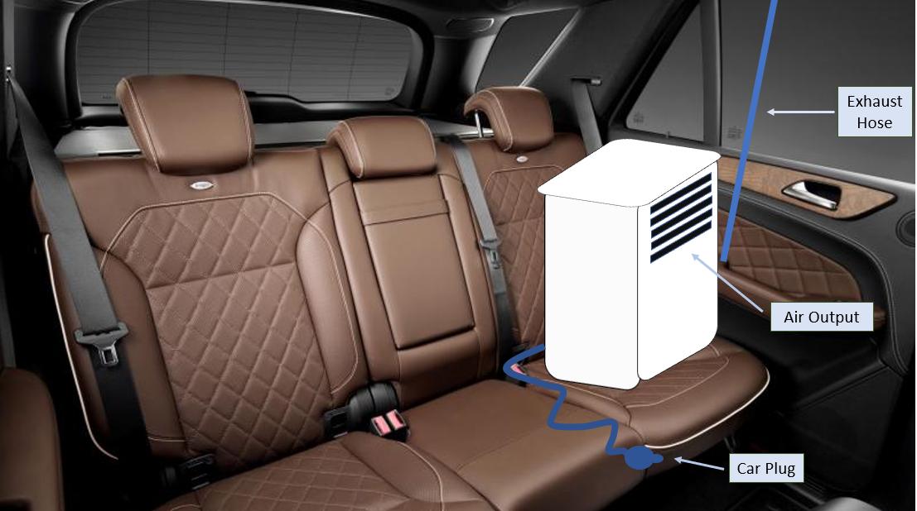

Figure 1. Seat Placement

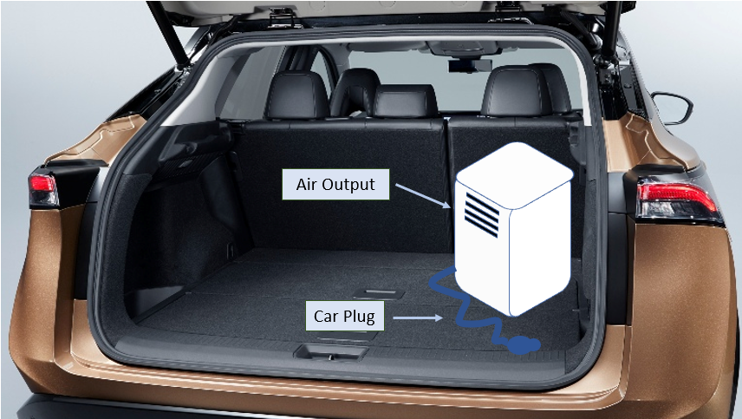

**Figure 2. Trunk Placement**

**Figure 3. Floorboard Placement**

## Responsibility and Change Authority

The team leader, Martin Rennaker, has the responsibility of verifying the project requirements. These requirements can only be changed with the approval of the team sponsor, Skyelar Head, and the team leader. The subsystem breakdown is as follows:

|  |  |
| --- | --- |
| **Subsystem** | **Responsibility** |
| VAC and MCU | Yarentzy Magallanes |
| Power Supply and Routing | Grant Franklin |
| Phone App and Interfacing w/MCU | Martin Rennaker |

**Table 1. Subsystem Leads**

# Applicable and Reference Documents

## Applicable Documents

The following documents, of the exact issue and revision shown, form a part of this specification to the extent specified herein:

|  |  |  |
| --- | --- | --- |
| **Document Number** | **Revision/Release Date** | **Document Title** |
| IEEE 802.15.4-2011 | 4/2011 | IEEE Standard for Local and metropolitan area networks--Part 15.4: Low-Rate Wireless Personal Area Networks (LR-WPANs) |
| IEEE 485-2020 | 6/2020 | IEEE Recommended Practice for Sizing Lead-Acid Batteries for Stationary Applications |

**Table 2. Applicable Documents**

## Reference Documents

The following documents are reference documents utilized in the development of this specification. These documents do not form a part of this specification and are not controlled by their reference herein.

|  |  |  |
| --- | --- | --- |
| **Document Number** | **Revision/Release Date** | **Document Title** |
| 1 | April 2011 | Temperature Variations in a Parked Vehicle |
| 2 | April 23, 2021 | How to calculate battery run-time |
| 3 | N/A | How To Maintain Batteries |

**Table 3. Reference Documents**

## Order of Precedence

In the event of a conflict between the text of this specification and an applicable document cited herein, the text of this specification takes precedence without any exceptions.

All specifications, standards, exhibits, drawings, or other documents that are invoked as “applicable” in this specification are incorporated as cited. All documents that are referred to within an applicable report are considered to be for guidance and information only, except ICDs that have their relevant documents considered to be incorporated as cited.

# Requirements

This section defines the minimum requirements that the development item(s) must meet. The requirements and constraints that apply to performance, design, interoperability, reliability, etc., of the system, are covered.

## System Definition

The Chilly Dog is a battery powered air conditioning unit paired with an application that cools the internal temperature of a vehicle with the purpose of creating a safe environment for a K-9. The Chilly Dog is broken into 4 systems as seen in Figure 3.1. They will all work together to provide sufficient cooling to the vehicle based on the user’s desired temperature. The Chilly Dog is made up by power, microcontroller, VAC, and application subsystems.

Figure 4: Block Diagram of System

The first stage of the block diagram is the power subsystem. Power is routed to the battery from a 18V, 100W solar panel. The solar panel will provide very slow recharging capabilities, so it will send power to the battery after going through a solar charge controller while the system is on. The battery will send voltage to the VAC and microcontroller subsystems, after going through converters to give the necessary voltages.

The microcontroller subsystem is in charge of controlling the air output from the VAC system. It will do this by comparing the current temperature in the vehicle from a sensor reading to the data sent from the application. If the two numbers don’t line up, the microcontroller will tell the VAC system to either stop blowing air if the car is too cold or to cool the car down if the current temperature is too high. The microcontroller will also read the outside temperature and battery life and send that information to the modem, which will send it to the application.

The VAC subsystem will take the input from the microcontroller and power from the battery and provide necessary cooling to the car. It will require an inverter to convert the battery input to an AC voltage, which is standard in VAC systems. Our VAC system will also handle the exhaust that comes with air conditioners.

The phone application sends data to the microcontroller based on what the user inputs through an internet connection. It will also receive the battery life, current car temperature, and outside temperature from the modem, which gets the data from the microcontroller. On the application, there will be options to input their pet’s size and a recommended temperature will appear, but they can set any temperature within a certain range for their dog. This will be the primary interface the user sees, other than the panel on the box with the power button.

## Characteristics

### Functional / Performance Requirements

#### Frequency of Temperature Measurements

Each temperature sensor in the Chilly Dog shall take a measurement every minute.

Rationale: This frequency is expected to report accurate temperature readings to the customer while avoiding recording excessive amount of data that could become difficult to manage. This frequency will also provide sufficient time for the customer to act if the temperature rises above the predetermined safe range.

#### Accuracy Of Measurements

The Chilly Dog sensors will report accurate data.

|  |  |
| --- | --- |
| **Sensor** | **Accuracy** |
| Cabin and Outside Temperature | + or - 1 ° C |
| Battery Life | + or - 1 % |

**Table 4. Measurement Accuracy**

Rationale: These are standard values that most sensors of decent quality can achieve. Accuracy of measurements are key in Chilly Dog as the health and comfortability of the customers pet is of essence.

#### Device Environment

The components of the Chilly Dog shall function in ambient temperatures of up to 130 degrees Fahrenheit.

Rationale: The Chilly Dog must be able to withstand extreme heat as it will be placed inside a vehicle.

#### Battery Operating Time

The Chilly Dog shall perform its entire functionality for a span of 1.3 hours.

Rationale: Per customer request. To provide the customer sufficient time to perform their tasks while their pet is in the vehicle.

#### Communication from Device to Application

Every minute The Chilly Dog will send updates to the app on cabin temperature, outside temperature, and current battery remaining. The app will send any updates the user makes on desired temperature within 5 seconds of them being made. These packets will be maximum 16 bits in size. As the device will be using cellular data as long as both the phone and device are connected to a cell signal it should work from any range, but the goal will be 500 yards for testing purposes.

Rationale: The goal is to keep the user as informed as possible so they can be sure that their pet is safe in the car.

#### Output Temperature Ranges

The Chilly Dog shall assume the car had been recently turned off and has an internal temperature of up to 85 degrees Fahrenheit before the device is powered. The Chilly dog shall then be able to output air with a minimum temperature of 62 degrees Fahrenheit.

*Rationale: The average car air conditioner has a cooling power of 17,000 BTU. This allows the car to cool quickly. The Chilly Dogs cooling power is 5,000 BTU maximum. The Chilly Dog shall be used for the sole purpose of maintaining the cabin temperature assuming it is less than 85 degrees Fahrenheit.*

### Physical Characteristics

#### Mass

The mass of the total Chilly Dog battery powered air conditioning unit shall be less than or equal to 127.8 pounds. This does not include the weight of the switchover circuit, microcontroller, or temperature sensor, which will affect the total weight minimally.

Current Component Mass Breakdown:

* AC Unit: 47.4 lbs
* Battery: 63.9 lbs
* Solar Panel:14.3 lbs
* Inverter: 2 lbs
* Microcontroller: TBD
* Temperature Sensor: 0.007 lbs
* Buck Converter (Total): 0.0708 lbs
* Solar Charge Controller: 0.27 lbs
* Modem: .089 lbs

Rationale: The Chilly Dog will have a wide mass range to work with thanks to the carrying capacity of a crossover vehicle. It will encompass the seat of one passenger. With this said, the Chilly Dog shall weigh less than the average passenger which weighs 136 pounds. Each physical component will be less than 65 pounds. This is to avoid the need for machinery during installation.

#### Volume Envelope

The volume envelope of the Chilly shall be less than or equal to 26 inches in height, 14 inches in width, and 14 inches in length. The Chilly Dog will only occupy the area of one seat but can be placed on the floorboard, or the trunk if desired. More detail can be found in the ICD.

Rationale: This is a requirement specified by our customer due to the limitation of the cabin space inside a vehicle. The customer expects sufficient room for their pet even after the Chilly Dog has been installed.

#### Mounting and Installation

The mounting information for the Chilly Dog System shall be captured in the ICD.

Rationale: The Chilly Dog includes the VAC unit, the exhaust hose, the connecting wires, and the solar panels. These details will be described in the ICD.

#### Material

The material of the Chilly Dog will be “pet friendly” meaning it will be made of nontoxic material to both the pet and the human, sturdy enough to resist accidental nudging, but shall not be expected to withstand chewing of cables and any other improper use.

#### Exhaust

The VAC unit will also have a hose connected to the window that will push the warm air outside of the car.

### Electrical Characteristics

#### Inputs

The electrical inputs for the Chilly Dog consist of the power from the solar panel, the temperature data gathered by the sensor on the microcontroller, and the user’s input information sourcing from the phone application.

##### Power Consumption

The maximum peak power of the system shall not exceed the available power coming from the battery, being 100W and 210W respectively.

Rationale: The power from the car outlet will recharge the battery much faster than the solar panel, so while driving to the destination, the user will use the car outlet and while the car is off, the solar panel will recharge the battery. The solar panel recharging time would be drastically reduced if a larger wattage panel is used.

##### Input Voltage Level

The input voltage level for the battery will be 14V, as is needed for the battery to recharge. The microcontroller will take 1.8 - 5.5V, the modem will take 5V at 50mA, and the VAC system will take 115V at 7.19A.

Rationale: The battery powered car air conditioning will need to power the microcontroller and the VAC components with enough voltage for the amount of time the unit will need to be running.

##### Modem Inputs

The modem will receive desired temperature data from the application, as well as the current temperature and battery life from the microcontroller.

##### Microcontroller Inputs

The microcontroller will receive inputs from temperature sensors and the modem. The temperature data from the sensors will be compared to the desired temperature data coming from the modem. If the actual temperature inside the vehicle is different than the desired temperature, the microcontroller will command the VAC system to output cool air.

Rationale: The microcontroller will oversee regulating the amount and the temperature of air that is output into the vehicle.

##### Application Inputs

The application will receive the current temperature data for the inside of the vehicle, as well as outside, and battery life from the modem.

Rationale: The app will need to display to the user the current internal car temperature, outside temperature, and battery life.

##### Air Conditioning Inputs

The VAC will receive commands from the microcontroller to turn/off its cooling.

#### Outputs

##### Modem Outputs

The modem will send the current temperatures and battery level to the application using cellular data.

##### Microcontroller Outputs

The microcontroller will send the current temperatures and battery level to the modem.

##### Application Outputs

The Application will send the user’s desired temperature to the modem. The application will also push notification banners to the phone to alert the user to low battery.

Rationale: The MCU will need the desired temperature from the app to know what temperature to set the car at. The app will need to notify users if there is danger to their animals

##### Air Conditioning Outputs

The unit will provide enough cool air that will bring the inside temperature of the car to the desired temperature input by the user.

Rationale: The unit will need to cool the car down fast enough so the pet inside the car will not overheat. It will also need to blow the hot air out of the car using an exhaust hose.

##### Cellular Outputs

The MCU will send both the current temperature and battery level to the app via cellular data.

Rationale: Allows the user to quickly check if the unit is operating correctly while away from the car, as well as informing them of the current battery life of the unit.

### Environmental Regulations

The Chilly Dog will need to withstand various climates and temperature ranges since its function is to keep the pet inside the vehicle safe while the weather is dangerous outside.

Rationale: This is a requirement specified by our customer due to constraints of their system in which the Chilly Dog is integrating.

#### Animal Activity

The Chilly Dog will be constructed to be resistant to animals biting or scratching it. It will also, as mentioned previously, be made out of nontoxic materials to prevent poisoning an animal that does bite or scratch it.

Rationale: This is to prevent injuries to animals in the car with the device as well as protecting the device from animals.

#### Weather Conditions

The only component that will be exposed to varying weather conditions will be the solar panel and the wires leading to the main unit. It will have to withstand weather conditions such as rain, humidity, etc. to satisfy the claim that it can run and charge a battery in all conditions.

#### Battery Input Regulation

Since the voltage coming from a solar panel is more than required to charge the battery, we regulate it with the solar charge controller.

#### Battery Output Regulation

There is a chance that the current will be too high between the load converters/inverter, so fuses are needed. These will be implemented in the wired connections from the converters/inverter to the battery.

### Failure Propagation

The Chilly Dog shall not allow propagation of faults beyond the Chilly Dog interface.

#### Connection Lost Between Modem and App

If the Modem and app lose connection, an attempt will be made 5 times, once per minute, to reestablish connection. If connection is not made and the phone can still connect to cellular data itself the app will send a banner notification to the phone informing them that connection has been lost and they need to return to their car. If the phone itself is unable to connect to cellular data, it is likely that the device is still functioning, and the app will simply send a notification every 5 minutes informing the user of how long it has been since a connection has been made.

# Support Requirements

### Android Device with Cellular Data

To Communicate with the Chilly Dog via the application, the customer will need access to an android device with cellular credit.

Rationale: Other forms of accessing the information from the system are outside of the scope of this project.

### Cellular Reception

The customer must have reliable cellular reception in the area where the Chilly Dog will be placed and where the customers phone will be located.

Rationale: The app and the device communicate through cellular signals.

### Crossover Sized or Smaller Vehicle

The customer must have a car that spans 179 inches (14 feet) in length or less.

Rationale: The use of the Chilly Dog in larger vehicles will not cool as expected and could result in the cabin being unfit for pets.

### Rolling Window

The customers crossover or smaller vehicle must have fully functioning windows that roll up and down.

Rationale: The Chilly Dog has an exhaust hose used to dispose of hot air. The exhaust hose configuration is only supported via a clip that attaches to a standard roll up window. Other configurations are not in the scope of this project.

### Provided

* (1) VAC unit
* (1) Rechargeable Battery
* (1) MCU
* (1) Cigarette Lighter Receptacle Plug in
* (1) Surface Mount Solar Panel
* (1) User Manual and Warnings
* (1) Installation Manual

# Appendix A: Acronyms and Abbreviations

lbs Pounds

AC Air Conditioning

V Volts

A Amps

mA Milliamp

MCU Microcontroller Unit

VAC Ventilation and Air Conditioning